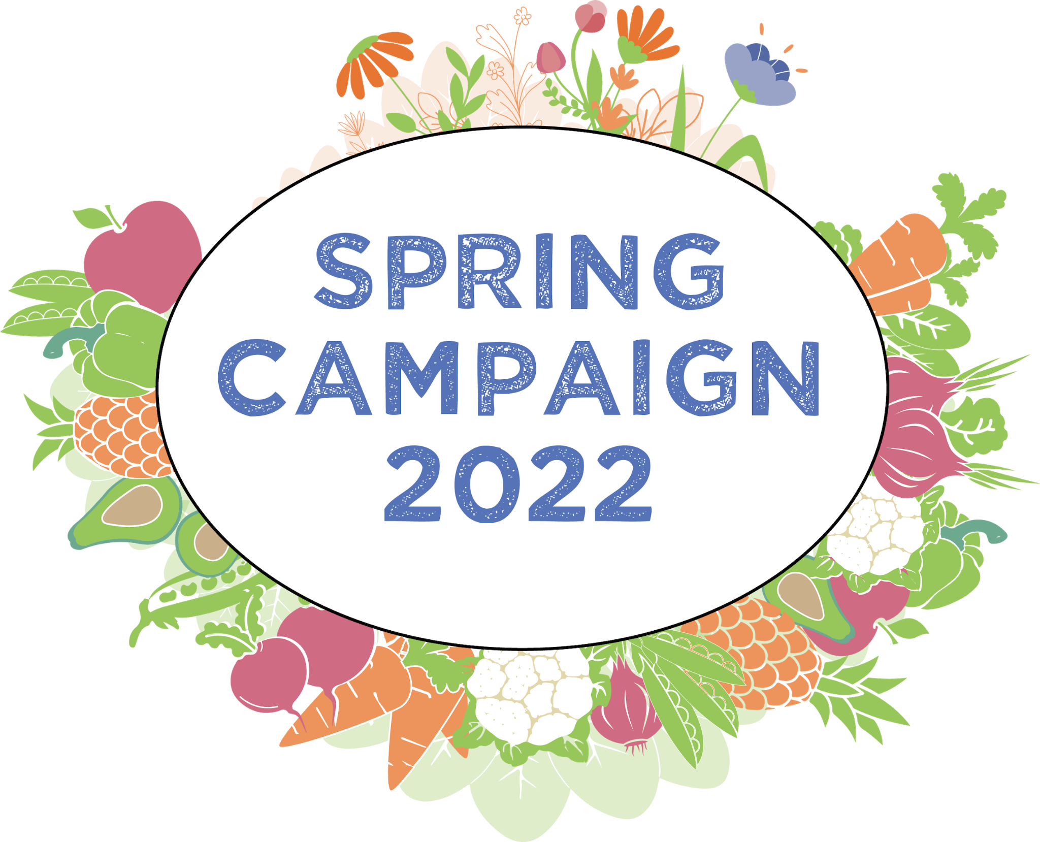

What is the West Side Campaign Against Hunger?

West Side Campaign Against Hunger (WSCAH) is one of the largest and most innovative food pantries in NYC. In 1979 WSCAH created the nation’s first supermarket-style pantry providing customers with a shopping pantry experience where they could choose the foods that best suited their needs. In 2017 WSCAH innovated again, flipping the conventional model of bringing people to food on its head. Working with community-based organizations to locate and reach food-insecure families, WSCAH’s Mobile Market brings healthy food directly to the most vulnerable communities across the city. Today, WSCAH is working on yet another innovation in emergency feeding, a Digital Choice Model. This model allows a customer to place an order from their phone, selecting between a choice of kinds of healthy food boxes and indicating the location they would like to get it. This is an exciting new approach that promises to bring the same ease and flexibility of online shopping to healthy food support.

WSCAH also provides benefits access services through its Social Services Department, which screens customers for eligibility for varied benefits, including SNAP (food stamps), health insurance, low-fare MetroCards, unemployment, etc. WSCAH helps eligible individuals and families navigate the benefits access process, ensuring that they can utilize the full extent of available support.

The COVID-19 Pandemic has severely impacted food insecure neighborhoods in all five boroughs. WSCAH temporarily suspended its choice pantry and moved our operations outdoors in response. We increased our food rescue and purchasing efforts and dramatically increased the reach of our Mobile Market, going from 15 partners pre-pandemic to over 60 last year. Our Social Services Department went virtual and performed increased outreach, including a large-scale SNAP (food stamps) awareness PSA in Northern Manhattan and The Bronx. As a result, WSCAH has grown from providing food for roughly 20,000 annually to over 77,000 last year.

WSCAH 2021 Overview
- 77,000 unique people received WSCAH services 356,000 times
- 4.3 million meals provided including 50% fresh produce
- $6.5 million in SNAP (food stamps) and other gained benefits
- A community effort, more than 1,500 volunteers donated over 14,000 hours to make WSCAH’s work possible

What is the Spring Campaign?
The Spring Campaign is a fundraising effort to support WSCAH’s springtime food distributions. Donated funds support the purchase and distribution of high-quality food including fresh fruits and vegetables, dairy, whole grains, and healthy proteins. A donation of $68 provides 1 box of healthy food, enough to support a family of three.

The Spring Campaign kicks off on April 1st and concludes on June 5th with WSCAH’s Rock the Block volunteering event! More details on the June 5th event will be forthcoming.

What is our goal?
Raise $200,000 throughout April and May
Provide 3,000 boxes of healthy food for families across NYC
Distribute 108,000 meals
Feed 9,000 people

How can I get involved?
Become a WSCAH peer-to-peer supporter and lead your own fundraiser for the 2022 Spring Campaign! If every person in the WSCAH community gave just one box of healthy food, we would reach our goal in a single day.

- Create a volunteer fundraising page here - it’s fast and easy. We’ve included some text to get you started, but please make it your own. Peer to Peer fundraising works the best when it's personal.
- Set a goal! WSCAH is aiming for 3,000 boxes of healthy food in April and May. How much do you think your network can contribute? 10 boxes? 100 boxes?
- Reach out to your network and encourage them to donate and spread the word about the Spring Campaign! Tell them why helping families this Spring is important to you. Posting to social media is great - but the strongest appeal will be a direct one. An email that explains why helping your fellow New Yorkers access healthy food will go a long way towards bringing in support.
- Amplify WSCAH’s message! Repost and forward our social media posts and emails throughout April & May.

2022 Spring Campaign Communications Tools

Image Library
Click here for the image library.

Email
Subject: Help me feed New Yorkers in need!

Dear (FIRST NAME),

I am writing to you as a supporter of the West Side Campaign Against Hunger (WSCAH), one of the largest and most innovative food pantries in New York. For over 43 years WSCAH has been providing tens of thousands of New Yorkers with healthy food and fresh produce, free of charge.

I’ve started a fundraiser for WSCAH’s Spring Campaign and I’m hoping you will consider contributing.

This April and May WSCAH is raising funds to support its citywide food access network. WSCAH serves more than 77,000 people annually with over 4.3 million meals. A donation of just $68 will provide a family with a four-day supply of high-quality food including 50% fresh produce. That’s a percentage of fresh fruits and vegetables unheard of in the food pantry system, and a testament to what makes WSCAH so special. The food is plentiful and nutritious!

My goal is to raise enough for (YOUR GOAL) boxes of healthy food by the end of May. Please donate and share with your network!

Click here to donate to my fundraiser (hyperlink to your personal fundraising page)
Thank you for supporting New Yorkers in need and helping to spread the word about this important issue!

Warm regards,

Social Media
Repost WSCAH’s social media through April and May or create a post of your own! Make sure to link to your personal fundraising page.

We’ve included some sample language to get you started - you can use this as-is, but we recommend you personalize. Tell your network why healthy food access is important - ask people to follow the link to donate and to repost. Use the pictures from the image library. Make sure to

- link to your fundraising page,
- tag WSCAH
- and use the Spring Campaign hashtag: #wscahspringcampaign.
- For Instagram posts include the link to your fundraising page in your bio!

1. For over 43 years WSCAH has been providing tens of thousands of New Yorkers with healthy food and fresh produce, free of charge. Join @WSCAH and me in our efforts to nourish hungry New Yorkers. From April through May we hope to raise enough funds to purchase healthy food for 9,000 WSCAH customers, providing 108,000 meals. Click here to donate (HYPERLINK TO YOUR DONATION PAGE). #wscahspringcampaign

2. Food insecurity can ruin the warmest spring day. You can help make an impact by donating to my @WSCAH Spring Campaign Fundraiser (HYPERLINK TO YOUR DONATION PAGE). $68 provides a family with a box of healthy food for 36 meals.
#wscahspringcampaign

3. Let’s make this is a hopeful Spring for all New Yorkers. Donate to @WSCAH to provide X boxes of healthy food and support my fundraiser (HYPERLINK TO YOUR DONATION PAGE)! $68 provides 1 family with a box of healthy food for 36 meals. Click here to donate, and pass it on #wscahspringcampaign

Social Media Handles
Facebook @wscah
Instagram @wscah_
Twitter @wscah

